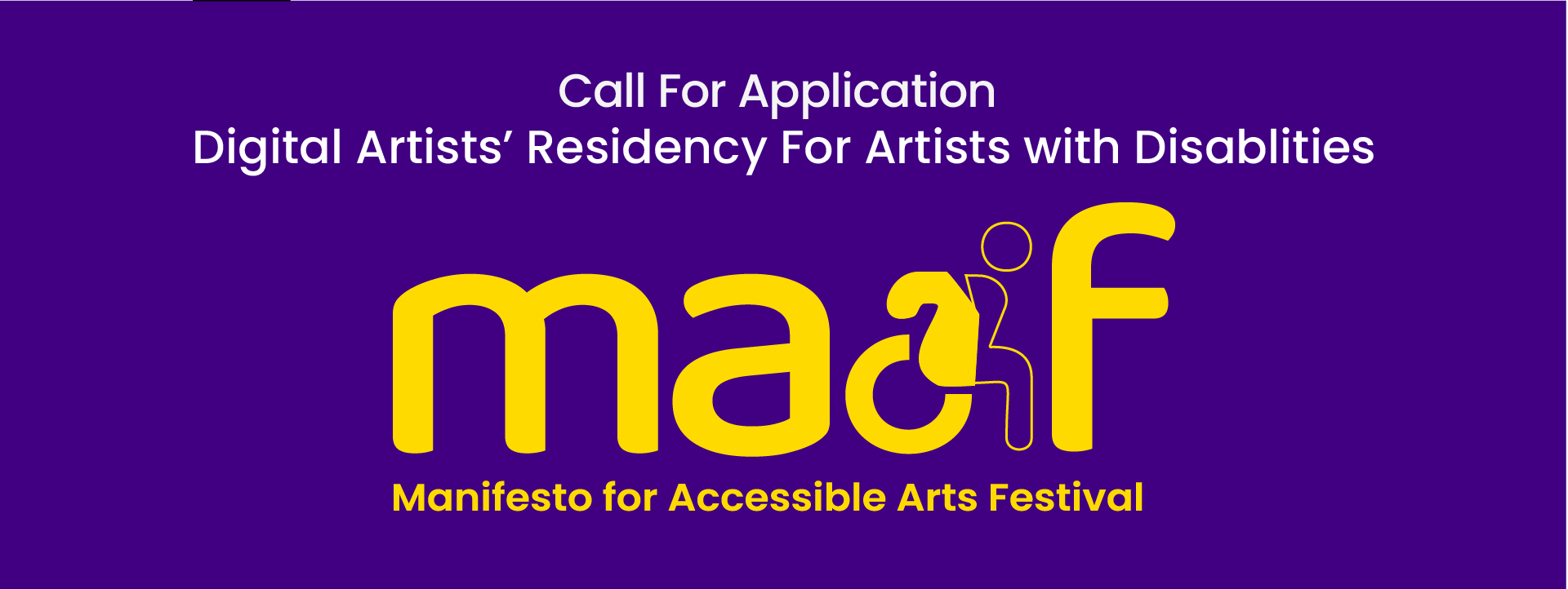

MAAF- Application Form

PERSONAL INFORMATION

Full name

Gender pronouns
Pronouns are very important now, it is very common to tell people your pronouns in a meeting. One reason is to have a safer space for people to self identify their gender if they are trans, or do not identify with the gender of their birth, or are non-binary in their gender and do not identify as either he or she. It also helps with equality of gender and make sure men, women and non-binary people are represented.

Please use the space below to self define your gender pronouns (if applicable)

Postal address

Email

Contact telephone number

Other methods of communication, e.g. Zoom, Facetime, WhatsApp etc

Your primary art form of the project is (select ONE only)
- Dance
- Literature
- Music
- Theatre
- Visual arts
- Combined arts
- Other (please state below)

Describe in just 500 words and tell us what would be your dream or your ultimate wish for an inclusive art festival?
The festival is about ‘Inclusive Arts’, which means the arts that every/anybody (artists or audiences) is able to appreciate, no matter whether you are mentally or physically challenged, or what sexuality, culture, and/or race you may be.

Other formats to answer the above question:
Upload an audio file (less than 5 mins in .mp3 format) or
Upload a video file (less than 5 mins in .mp4 format)

UPLOAD BUTTON

SUPPORTING DOCUMENTS
You may provide some examples of previous work, and/or documentation of your work.

Websites (optional)
You can add links to up to three other websites or locations of other documented work online.

Add images (optional)
Image description/passwords (if applicable) -

Add a video link (optional).
Video description/password (if applicable)

Add audio (optional)
Audio description/password (if applicable)

NOTE:
If you are using the Word File to submit your application then, please attach all the supporting documents (if any) with the application form and email them to reachmaaf@gmail.com

If you have any questions please contact us directly by emailing - reachmaaf@gmail.com

